# Experiment 5

**Student Name:** Saurabh Kumar **UID:** 22BCS11917

**Branch:** BE - CSE **Section:** 702 - B

**Semester:** 5th **Date of Performance:** 27/08/24

**Subject Name**: Computer Networks **Subject Code:** 22CSH – 312

1. **Aim:** Implement Data link layer Protocols such as CSMA, CSMA/CD etc.
2. **Objective :-** Students will understand working of CSMA,CSMA/CD and Data link layer
3. **S/W Requirement :-** Packet Tracer or NS2

## H/W Requirement:-

* + **Processor** – Any suitable Processor e.g. Celeron
  + **Main Memory** - 128 MB RAM
  + **Hard Disk** – Minimum 20 GB IDE Hard Disk
  + **Removable Drives**–1.44 MB Floppy Disk Drive –52X IDE CD-ROM Drive
  + PS/2 HCL Keyboard and Mouse

# Theory:

The data link layer, which is the second layer of the OSI (Open Systems Interconnection) model, is responsible for node-to-node data transfer and error detection/correction. Several protocols manage these tasks, including Carrier Sense Multiple Access (CSMA) and its variant with Collision Detection (CSMA/CD).

## Carrier Sense Multiple Access (CSMA)

CSMA is a network protocol that controls access to the transmission medium by ensuring that devices check whether the medium is free before attempting to send data. This "carrier sensing" helps to reduce the chances ofcollisions, which occur when two or more devices transmit simultaneously.

## Key Concepts in CSMA:

* + **Carrier Sensing:** Before sending data, a device listens to the communication medium to detect if it isbusy or free. If the medium is busy, the device waits for it to become free.
    - **Random Backoff:** If the medium is busy, the device waits for a random amount of time before checking again. This random delay reduces the likelihood that two devices will attempt to transmit simultaneously after the medium becomes free.

## Carrier Sense Multiple Access with Collision Detection (CSMA/CD)

CSMA/CD is an extension of CSMA designed to handle the possibility of collisions more effectively, which is crucial in networks like traditional Ethernet. This protocol ensures that the network remains stable and that data is eventually transmitted successfully, even in high-traffic conditions.

## Key Concepts in CSMA/CD:

* + - **Collision Detection:** Devices monitor the network while transmitting data. If a collision is detected (i.e.,two devices transmit simultaneously), the devices immediately stop transmitting.
    - **Jamming Signal:** After detecting a collision, devices send a jamming signal to ensure all other devices are aware of the collision.

## Implementation Considerations

When implementing CSMA or CSMA/CD, the following considerations are essential:

* + - **Simulation Environment:** A simulation environment is often used to model network conditions and thebehavior of protocols under different traffic loads. This helps in visualizing and understanding how these protocols manage medium access and collisions.
    - **Protocol Efficiency:** The efficiency of CSMA and CSMA/CD is highly dependent on network conditions. High traffic can lead to frequent collisions, especially in CSMA/CD, making the backoff strategy critical in maintaining network performance.
    - **Scalability:** The protocols should be tested in environments of varying sizes to assess how well they scale. For instance, CSMA/CD's effectiveness can diminish as network size increases, leading to the adoption of more advanced protocols like Ethernet's switch-based mechanisms.

# OUTPUT: CSMA/CD COLLISION:-

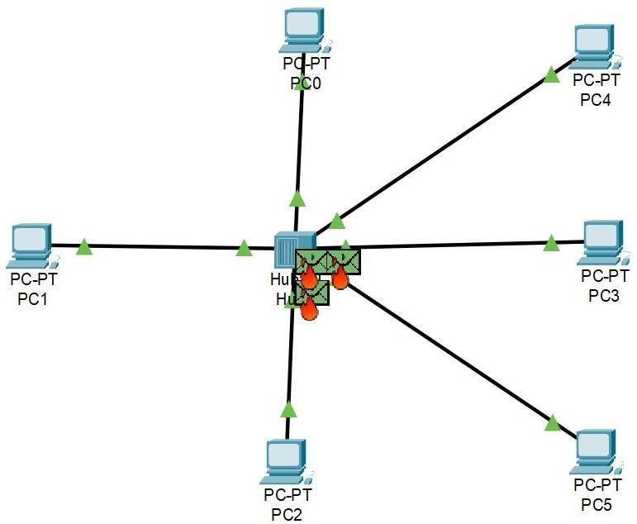

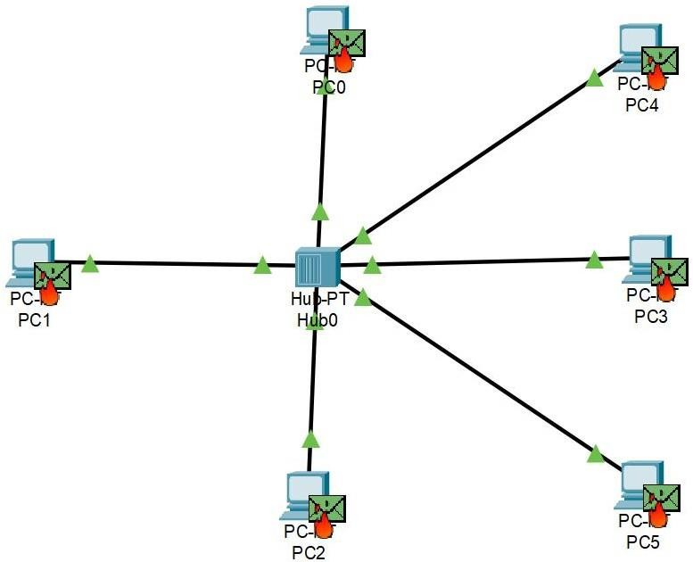

1. **Learning Outcomes:**

* **Understanding Protocol Mechanics:** Gain a deep understanding of how CSMA, CSMA/CD, and otherdata link layer protocols operate, including how they handle collisions and manage network traffic.
* **Simulation and Implementation Skills:** Develop the ability to simulate and implement these protocols ina programming environment, which involves coding, debugging, and testing.
* **Network Performance Analysis:** Learn to analyze the performance of these protocols under differentnetwork conditions, including high and low traffic scenarios, and understand their strengths and limitations.
* **Problem-Solving in Network Design:** Improve problem-solving skills by tackling challenges that arise innetwork design, such as minimizing collisions and optimizing data flow.